1. Top and Bottom Performing Cities
   * Identify the top 3 and bottom 3 cities by total trips over the entire analysis period.
   * 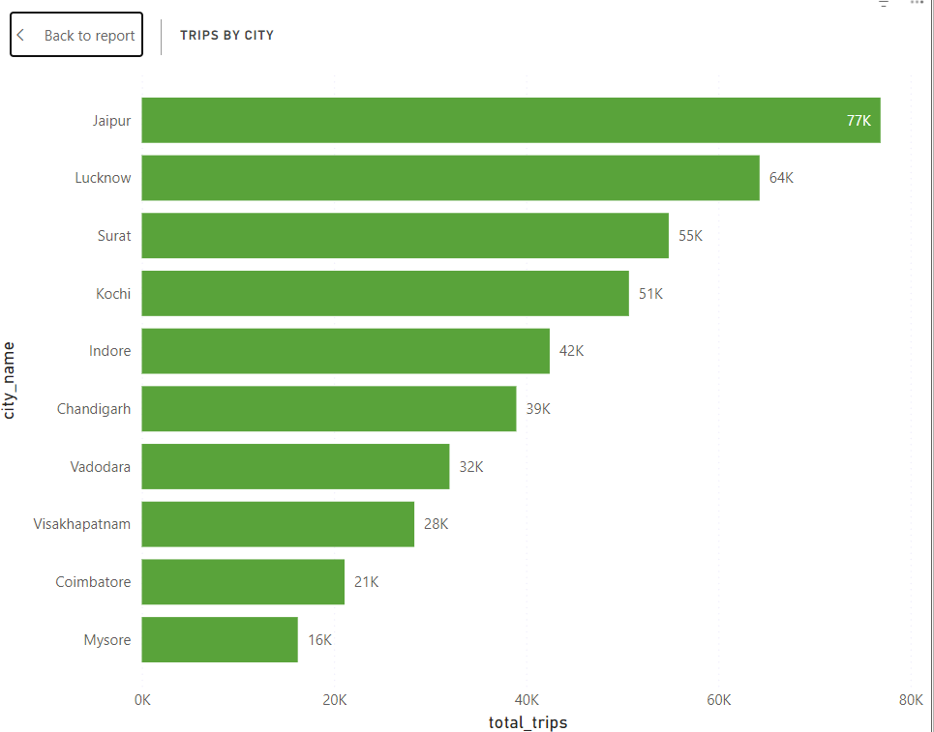
2. Average Fare per Trip by City
   * Calculate the average fare per trip for each city and compare it with the city's average trip distance. Identify the cities with the highest and lowest average fare per trip to assess pricing efficiency across locations.
   * 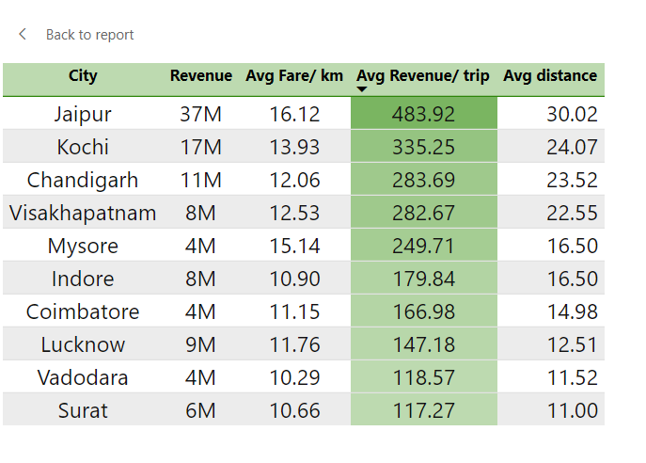
3. Average Ratings by City and Passenger Type
   * Calculate the average passenger and driver ratings for each city, segmented by passenger type (new vs. repeat). Identify cities with the highest and lowest average ratings.

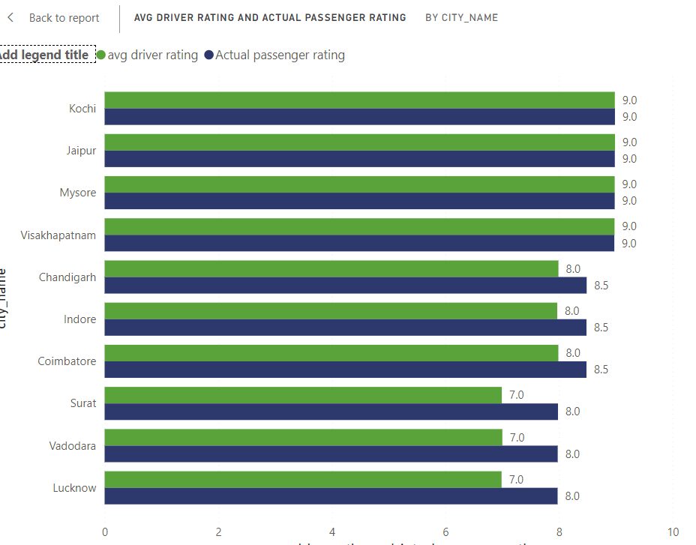

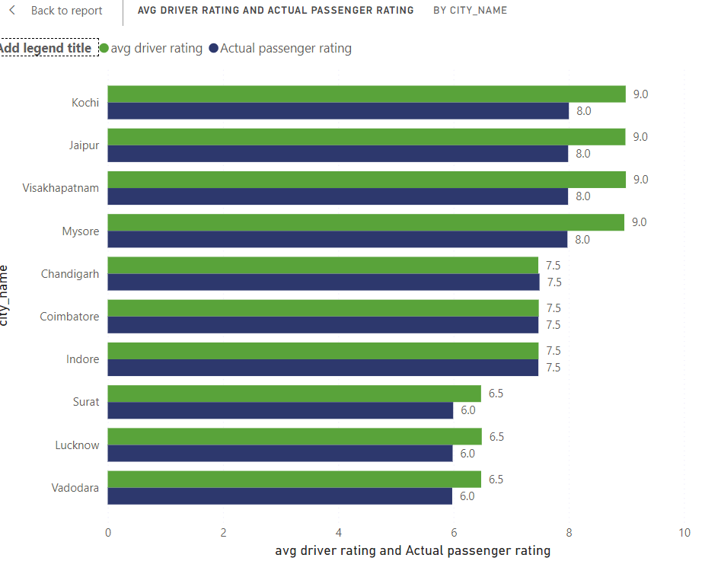

1. Peak and Low Demand Months by City
   * For each city, identify the month with the highest total trips (peak demand) and the month with the lowest total trips (low demand). This analysis will help Goodcabs understand seasonal patterns and adjust resources accordingly.
   * 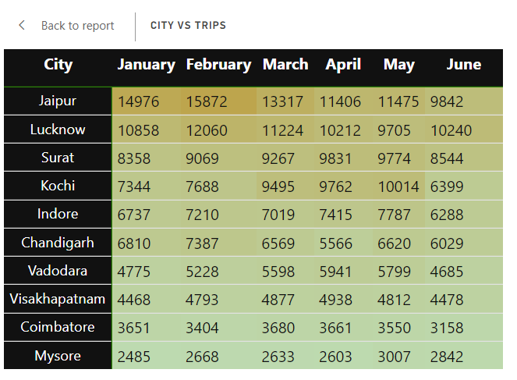
2. Weekend vs. Weekday Trip Demand by City
   * Compare the total trips taken on weekdays versus weekends for each city over the six-month period. Identify cities with a strong preference for either weekend or weekday trips to understand demand variations.

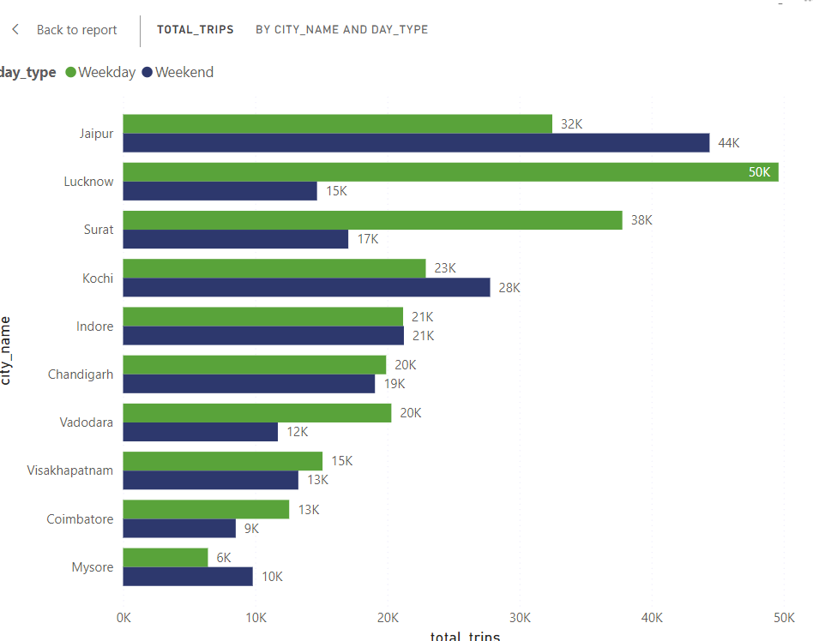

1. Repeat Passenger Frequency and City Contribution Analysis
   * Analyse the frequency of trips taken by repeat passengers in each city

(e.g., % of repeat passengers taking 2 trips, 3 trips, etc.). Identify which cities contribute most to higher trip frequencies among repeat passengers, and examine if there are distinguishable patterns between tourism-focused and business-focused cities

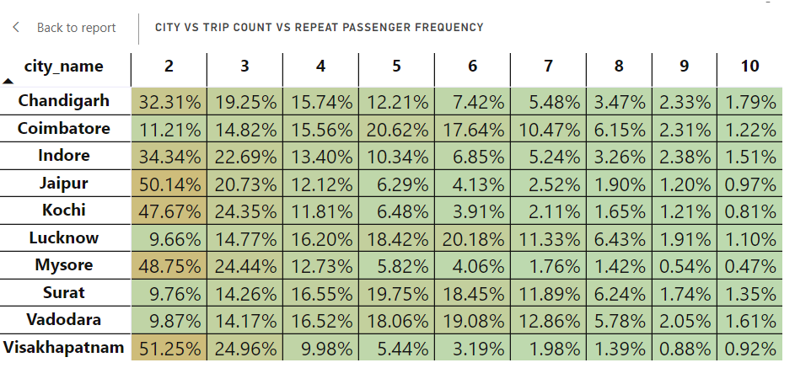

1. MonthIy Target Achievement Analysis for Key Metrics
   * For each city, evaluate monthly performance against targets for total trips, new passengers, and average passenger ratings from targets_db. Determine if each metric met, exceeded, or missed the target, and calculate the percentage difference. Identify any consistent patterns in target achievement, particularly across tourism versus business-focused cities.

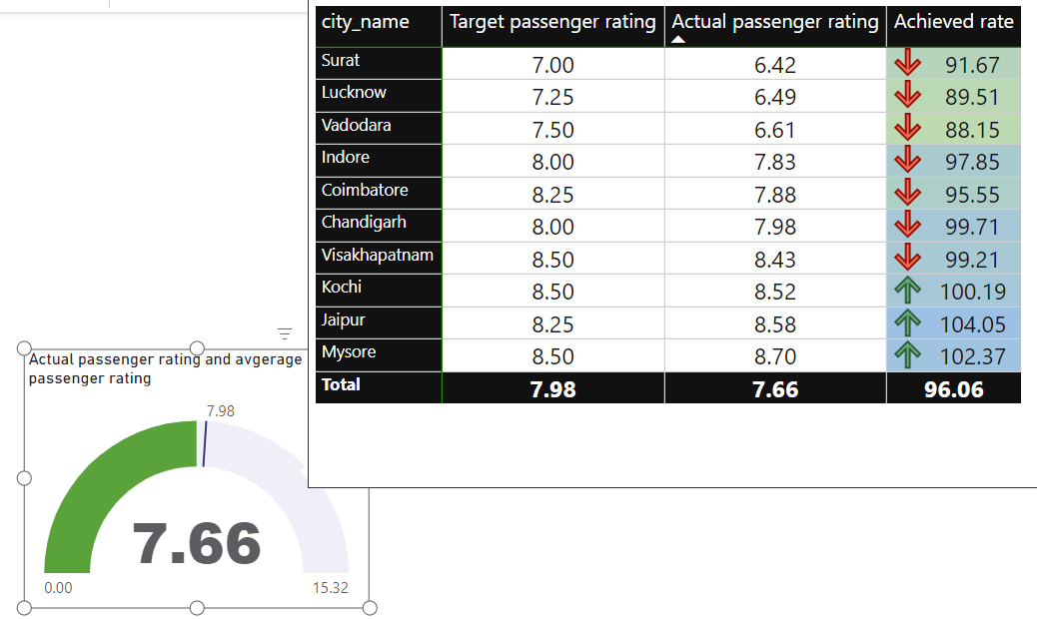

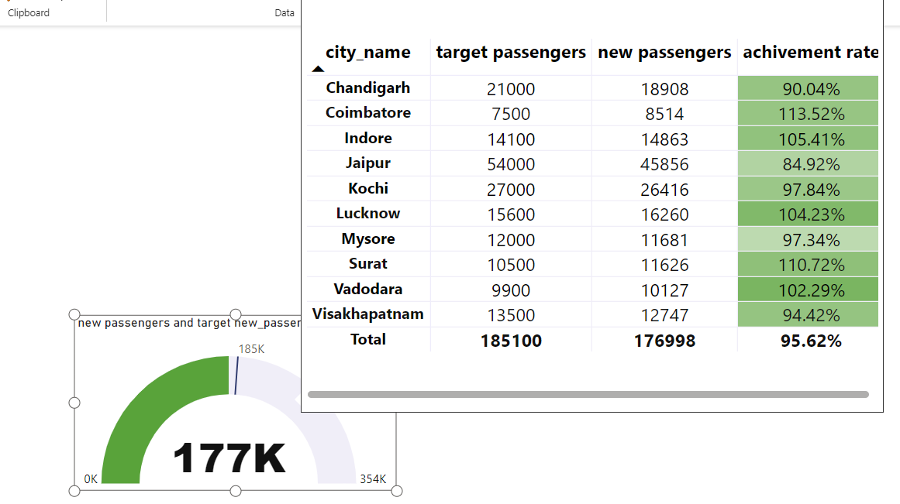

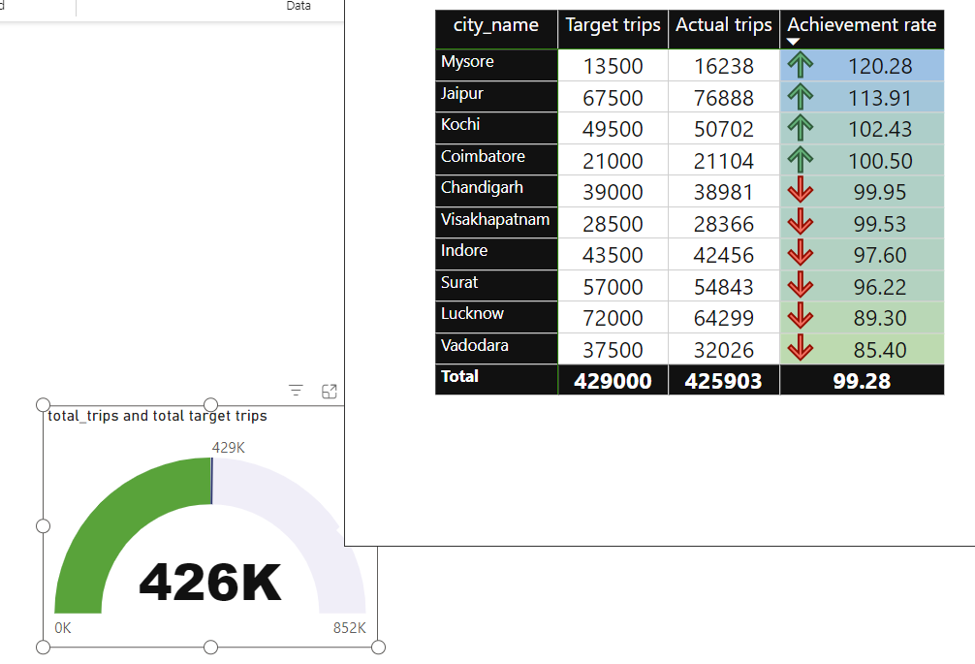

1. Highest and Lowest Repeat Passenger Rate (RPR%) by City

